**Problem background**

**Background**

As social media platforms become popular among youngsters, there has been a surge in finding tourist attractions or check-in locations to get “likes” and “followers”. “打卡”is what Hongkongers call it.I also keep up with the trend and take photos at the top tourist attractions to post on social media. However, I spent extra time and effort to find what are the spots that cater to my needs. For example, when I searched for “打卡” online, all of the results are simply articles from different websites that list top 10 suggestions, as shown from the figure1. There is also no website that is specifically for finding “打卡點”(check-in locations). The scattered information online has led to great inconvenience. People may have diverse purposes such as finding the spots where movies or mv are taken, or where they can pretend to be sporty.

**Objective**

Therefore, I want to build a website that aggregates different tourist attractions with photos,reviews and related tips into an organized data. The main purpose of this website is to help people save their time from finding the spots that serve their diverse needs.

**Target Audience**

The target group is KOL because they have an urgent need to promote themselves and are willing to pay for promotion. This hypothesis is validated after the conduction of a usability test with a KOL. By targeting this group of people, a business case is thus created and contributed to the website’s sustainability.

**Problem Statement**

The problem statement is How might we make a KOL address the problem of efficiently finding the right check-in place to go and post beautiful photos on social media to achieve the goal of making good use of her time to promote herself?

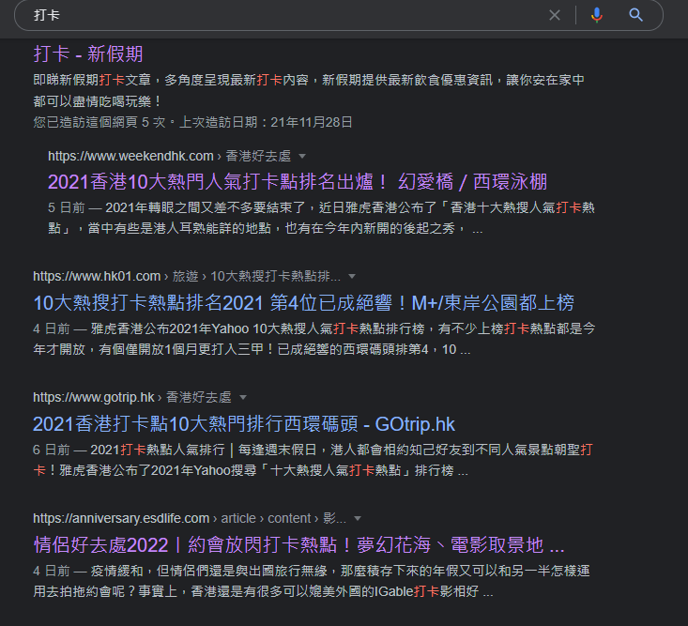

Figure1. Search Results

**Requirements**

**Functional and information requirements**

Our target Persona is KOL and as a KOL, they want to take beautiful pictures at unique places and promote themself f so that they could get more followers for their social media account. Based on the needs of the persona, I have developed several functional and information requirements.

| Function | User Story | Requirement |
| --- | --- | --- |
| Filter | As a KOL, I want to be able to filter the results | The system must allow users to filter the results by styles, categories, region and price range. |
| Booking | As a KOL, I want to be able to book hotels,restaurants or attractions | The system must redirect the users to the locations booking system |
| Discussion forum | As a KOL, I want to be able to share my tips and photos taken at the location | The system must allow users to create posts with pictures and text |
| Weather parameters | As a KOL, I want to be able to check the weather | The system must allow users to check the current weather of different regions in Hong Kong |
| Photo gallery | As a KOL, I want to be able to browse the related photos of the location | The system must allow users to browse the related photos of the location by having a photo gallery |
| Clothing suggestions | As a KOL, I want to be able to get clothing inspiration | The system must allow users to find clothing suggestions based on different occasions |
| Bookmarks | As a KOL, I want to be able to save locations and articles in bookmarks | The system must allow users to bookmark their choices and check their bookmarks anytime |
| Boost Post | As a KOL, I want to be able to boost my posts exposure | The system must allow users to join our affiliate program that provides privileges, such as exclusive code and boost post function |
| Login and Signup | As a KOL, I want to be able to create an account on the website | The system must allow users to create an account and login to see the profile page |
| Profile | As a KOL, I want to be able to have a profile page that showcases my followers and timeline | The system must allow users to have a profile page after logging in |

**Data research**

The information of check-in locations are found on Tripadvisor, Klook and kkday. The current weather data in Hong Kong from the “weather” page is retrieved from the data in the openweather API. The interactive map from the “contact” page is created by using Leaflet (an open-source JavaScript library) and Openstreetmap.org.

**Strategy**

As a travel guidance website, our strategy is to enter into the KOL market, focusing on one of the most important pains of KOLs’: finding the best places to shoot good photos and getting more promotions by providing tools like marking the interesting moments in discussion forums. It is a win-win situation as they could contribute content for the website while boosting their social media traffic. Through aggregating KOL and other users’ comments with the latest check-in locations’ information, we aim to create a social space that forms collective memories.

**Design**

**Color**

The main color schemes of DACARD are tiffany blue(#34b7a7),red(#F56961) and white(#fff). The colors are combined to create a striking yet balanced visual effect. At the same time, it creates a lively and youthful feeling for the website. These colors are not only pleasing to the eye, they also contribute to the brand identity of the company. Moreover, the colors are used based on different purposes. White is mainly used as the background color as it provides a clean canvas for the website and does not distract the users from the main content. The sharpest colors, blue and red, are used on the most important things that I want the users to see. From the “Affiliate Program” page, it could be seen that the “JOIN NOW”button, “BUY NOW” buttons and the “premium plan”are highlighted on the page in blue.

**Font**

The font types that the website mainly uses are Raleway and apple-system font. Raleway is used for the fonts from the navigation bar, while apple-system is used for the title of each section and main content. The sleek fonts help to set a clean and professional tone for the website and enhance the readability of the text.

**Grid**

Overall, The website makes use of a 12 column grid and every important design element is included inside. As for the “explore” page, it uses a 3 column modular grid to organise the suggested places. The image, name, price and opening hours are organized row by row. On the left of the page, there is a sidebar for filters section in which users can easily modify the results according to their preference.

**Test/evaluation**

**Usability**

I have conducted a usability test with Chrissy who is a KOL on instagram. Her Ig account is chrisssssssyxx. The tasks that I ask her to perform are 1.Find and book a trip to Hong Kong Disneyland, 2. Look for information to get prepared before going out, 3.Promote yourself and boost your posts’ exposure, 4. See others’ reviews and articles, 5.Look for the bookmarked items. She completed most of the tasks successfully. The only task that she stuck at is to boost post exposure. She spent 16 seconds finding the boost post button. Yet, she thought it would be better if I could include a map that shows the location of the places on every “details” page. At the end of the test, I asked her what she likes or doesn’t like about the website. She likes the clear layout and design of the website which is user-friendly and eye-catching. Some pages are also very interesting and useful as well such as the “clothing” page. She is also surprised that the website offers an affiliate program which provides what she wants. The only thing she thought could be improved is that the price of the plans are a bit high but she is still willing to pay for it.

Another user that I have conducted a usability test with is Amber who is also a KOL. Her instagram account is amber.215am. She has successfully completed most of the tasks. The task that she has encountered is task 1. Since she will usually search for the locations on the website to get to the information directly and quickly, it is quite inconvenient for her to locate the link to Hong Kong Disneyland by going through several pages. At the end of the test, I asked her what she likes or doesn’t like about the website. She likes the “clothing” page and “detail” page. The idea of “clothing” page is pretty new to her and the “detail” page has shown all the information she needs to know. As for the affiliate page, she thinks she will join the program if there are enough users on the DACARD platform.

I have conducted a usability test with Jenny who is outdoorsy and likes to take photos. Like the last user, she completed most of the tasks successfully. At the end of the test, I asked her what she likes or doesn’t like about the website. She thought that the sections from the nav bar were clearly divided and the “weather” and “clothing” pages were useful too. However, she thought the “affiliate program” would be attractive to the KOLs. However, since she is not a KOL, she is not interested in it.

Jonathan is another user that I have conducted a usability test with. His hobby is photography. After performing all of the tasks, he didn’t encounter many issues. However, he has some suggestions for my website. He thought the “Tips & Resources” section can include a route planner page which allows him to check the distance from one place to another and the time required. As for what he likes about the website, he thinks it is good to have his own profile.

The last user that I have conducted a usability test is Chris who loves phototaking as well. He has also successfully completed all of the tasks. At the end of the test, I asked him what he likes or doesn’t like about the website. He thinks the website is easy to use and informative. He also found that it is interesting to see that users can create posts that showcase their photos. However, he thinks the affiliate program is not very useful to him, instead he wanted to get some benefits from the website such as discount codes and referral code in which he can get bonus by introducing people to the website.

**A/B Test Results**

I have created one variant for the homepage. The original caption ‘Explore check-in locations in Hong Kong’ is changed to ‘Explore and book check-in locations in Hong Kong at exclusive prices! ’. The goal is set to be the bounce rate.

According to figure 2, after 3 days of experiments, the data showed that variant 1 has 1 experiment bounce from 12 experiment sessions, while original has 0 experiment bounce from 5 experiment sessions. The calculated bounce rate of variant1 is 8.33% while original is 0%. The original version’s possibility to be best is 55% and the variant’s possibility to be best is 45%. Thus, the original version is the better version to be used due to its low bounce rate.

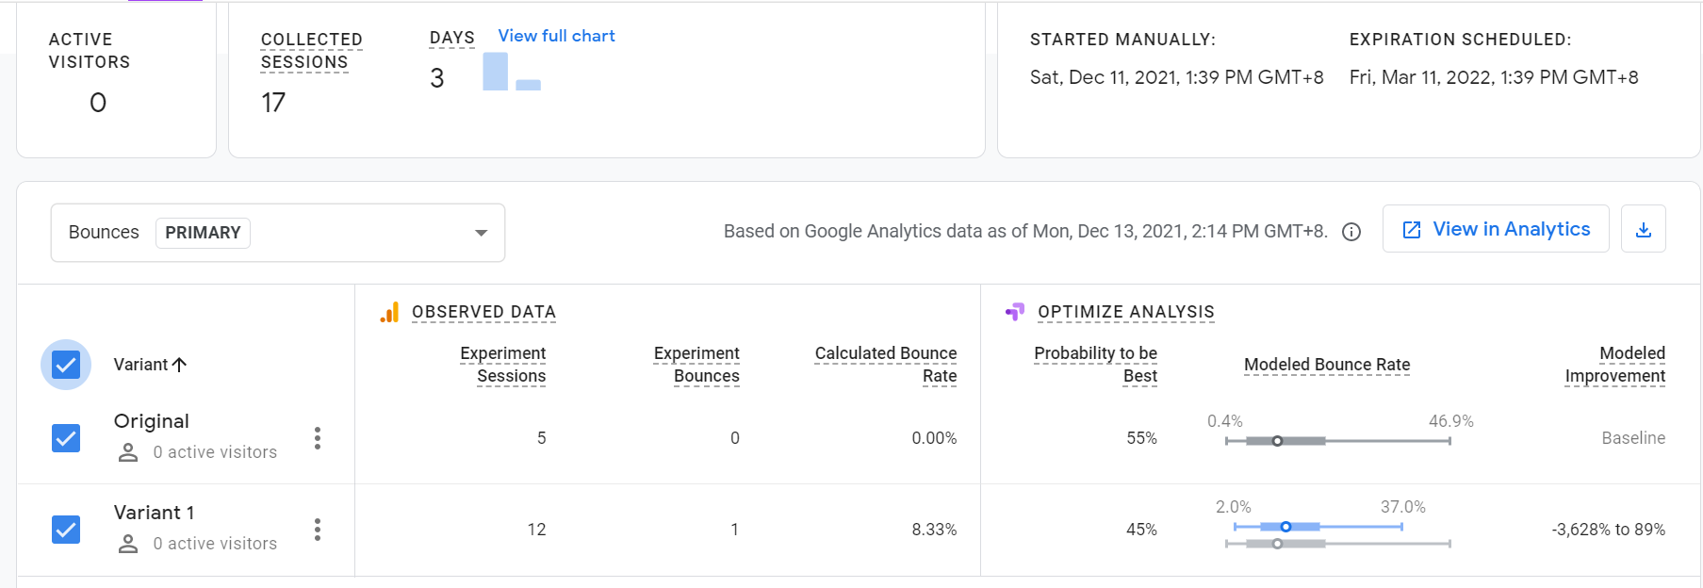

*Figure2.* Google optimize results

**Recommendations**

In order to make the website a sustainable product, I need to expand the market to the general public. As it could be seen from the usability test, people who is not KOL wants to have more features for them. To keep them as our users, I need to create more interesting features that attract them to use our website. By having more users, the website can have a saturated user base and can attract more KOLs to join the affiliate program.

Moreover, to attract more users to choose my website instead of other competitors, I need to create some discount or coupons for the users by cooperating with other travel agency websites and companies.

**Appendix A**

Figma Prototype:

<https://www.figma.com/file/d3Jd1SO5A0QLEZH3bXL9lB/DACARD?node-id=0%3A1>

**Appendix B**

3rd party Bootstrap templates:

1.Kelly - Bootstrap CV Resume HTML Template

<https://bootstrapmade.com/kelly-free-bootstrap-cv-resume-html-template/>

2.Socimo - Social Network & LMS Ultimate Responsive Template

<http://preview.themeforest.net/item/socimo-social-community-network-and-lms-template/full_screen_preview/29912016?_ga=2.221945117.463757195.1637830276-1028651985.1637655112>

3.Tour Packer - Agency WordPress Theme

<http://preview.themeforest.net/item/tour-packer-tour-agency-wordpress-theme/full_screen_preview/16480138?_ga=2.41178023.463757195.1637830276-1028651985.1637655112>

4.TheEvent - Free Event and Conference Bootstrap Template

<https://bootstrapmade.com/theevent-conference-event-bootstrap-template/>